LAB EXERCISE 6 – DATABASE

1 - Write the code that adds an index to the my_guitar_shop database for the zip code field in the Addresses table.

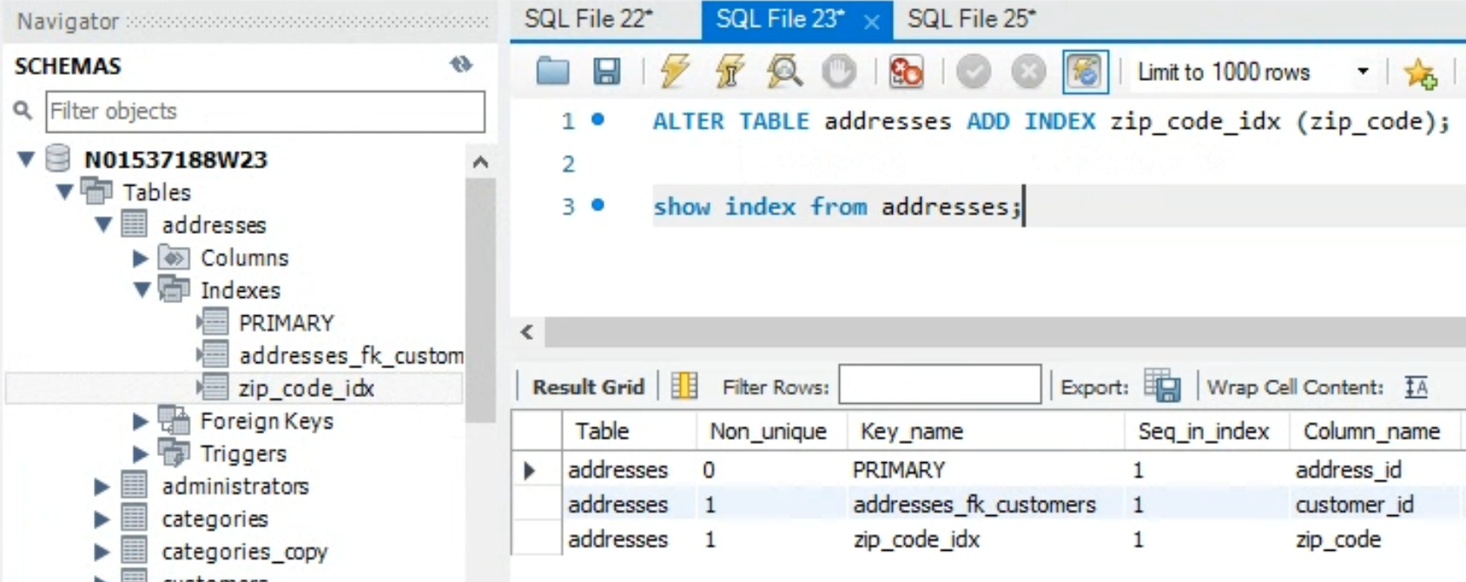

2. … Create the following